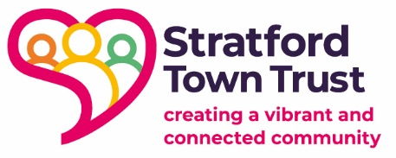

Stratford Town Trust – 2025 Guidance Notes Summary (for Applicants)
Introduction
As you prepare your grant application to Stratford Town Trust in 2025, you’ll find several guidance notes designed to support you through the process. Each one offers practical advice to help you strengthen your application, better understand what we’re looking for, and maximise your project’s impact. This summary gives you a quick overview of each guidance note, helping you decide which ones are most relevant to your application.

Consultation Guidance 2025
This guidance will help you show how your project has been shaped by the people it aims to benefit. It offers practical advice on how to carry out meaningful community consultation and explains why it’s important for your application. If you want to demonstrate that your work responds directly to local needs, this guide is essential reading.
Core Funding Impact Guidance 2025
If you are applying for core funding (rather than project-specific funding), this note will help you explain the wider difference your organisation makes. It focuses on how you can show the value of your ongoing work, your role in the community, and the impact of building your organisation’s resilience through core support.
Placemaking Guide 2025
This guide is for applicants who are involved in improving spaces, facilities, or the local environment. It introduces the idea of placemaking — creating welcoming, inclusive spaces that bring people together — and offers a simple framework to help you think about how your project could contribute to a stronger, more connected community.
Participatory Grant Making Overview 2025
This overview explains a key part of our approach: putting local people at the heart of decision-making. If your grant is part of a participatory process, this guide will help you understand what participatory grant making is, how it will affect the application process, and how we are working to make funding decisions fairer and more community-led.
Monitoring and Evaluation Guidance 2025
If you are wondering what information you’ll need to report back after receiving a grant, this guidance sets it out clearly. It explains how to plan simple, meaningful monitoring and evaluation that focuses on learning and improvement, not just ticking boxes — making it easier for you to share the difference your work makes.
Demographic Information Guidance 2025
We ask for some basic demographic information about the people your work reaches. This short guide explains why we collect this information, how you can gather it appropriately and sensitively, and how it helps us make sure our funding reaches all parts of the community fairly.

